**PRACTICAL-2**

**Aim: Implement and analyze algorithms given below.(Compare them)**

**2.1 Bubble Sort:**

**PROGRAM:**

#include <iostream>

using namespace std;

int main()

{

int arr[50];

int n,i,j,temp,c=0;

bool swapped;

cout << "Enter size of array : ";

cin >> n;

cout << "Enter " << n << " elements : ";

for (i=0; i < n; i++)

cin >> arr[i];

for (i = 0; i < n-1; i++) {

swapped = false;

for (j = 0; j < n-i-1; j++) {

c++;

if (arr[j] > arr[j+1]) {

temp = arr[j];

arr[j] = arr[j+1];

arr[j+1] = temp;

swapped = true;

}

}

if (swapped == false)

break;

}

cout << "Sorted array:";

for (i=0; i < n; i++)

cout << " " << arr[i];

cout << "\nCounter = " << c;

return 0;

}

**OUTPUT:**

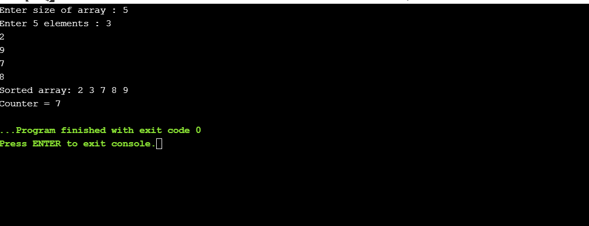

**ANALYSIS TABLE:**

|  |  |
| --- | --- |
| **SIZE OF SET** | **COUNTER** |
| 5 | 7 |
| 4 | 6 |
| 7 | 20 |
| 11 | 55 |
| 1 | 0 |

**GRAPH:**

**CONCLUSION:**

In this practical we can conclude that bubble sort algorithm behavior is non-linear.

**Aim: Implement and analyze algorithms given below.(Compare them)**

**2.2 Selection Sort:**

**PROGRAM:**

#include<iostream>

using namespace std;

int counter=0;

int main()

{

int length;

coot<<"Enter the size of array :";

cin>>length;

int arr[length];

for (int i=0;i<length;i++)

{

arr[i]=i+10; cout<<"Enter element"<<(i+1)<<":";

cin>>arr[i];

}

for(int m=0;m<length;m++)

{

int minimum=m;

float temp;

for(int n=m+1;n<length;n++)

{

counter++;

if(arr[n]<arr[minimum])

{

minimum=n;

}

}

temp=arr[m];

arr[m]=arr[minimum];

arr[minimum]=temp;

}

cout<<endl<<endl<<"Sorted Array is: " <<endl;

for(int i=0;i<length;i++)

cout<<arr[i]<<" ";

cout<<"\nCounter :" <<counter<<endl;

}

**OUTPUT:**

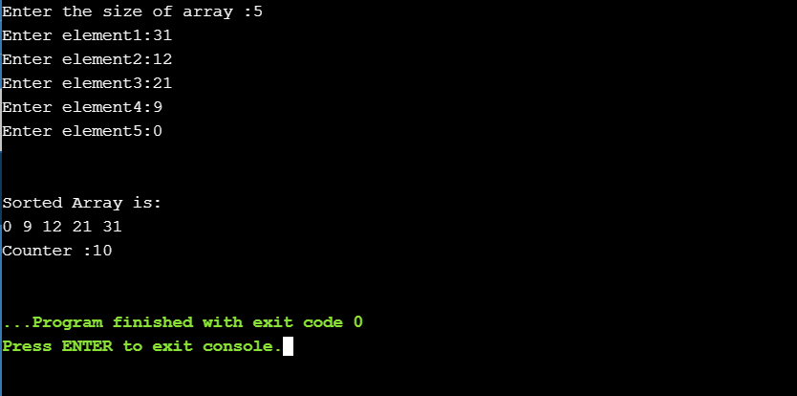

**ANALYSIS TABLE:**

|  |  |
| --- | --- |
| **Size Of Array** | **Counter** |
| 5 | 10 |
| 3 | 3 |
| 10 | 45 |
| 12 | 66 |
| 9 | 36 |

**GRAPH:**

**CONCLUSION:**

In this practical we analyzed the graph of selection sort

**Aim: Implement and analyze algorithms given below.(Compare them)**

**2.3 Insertion Sort:**

**PROGRAM:**

#include<iostream>

using namespace std;

int counter=0;

int main()

{

float temp;

int i,j,length;

cout<<"\nEnter the size of Array:";

cin>>length;

int arr[length];

cout<<"Enter Array elements: "<<endl;

for(i=0;i<length;i++)

{

cin>>arr[i];

}

for(i=1;i<length;i++)

{

temp=arr[i];

j=i-1;

counter++;

while((temp<arr[j])&&(j>=0))

{

counter++;

arr[j+1]=arr[j];

j=j-1;

}

arr[j+1]=temp;

}

cout<<"\nArray after Being sorted : \n";

for(i=0;i<length;i++)

{

cout<<arr[i]<<" ";

}

cout<<"\n\nCounter :"<<counter<<endl;

return 0;

}

**OUTPUT:**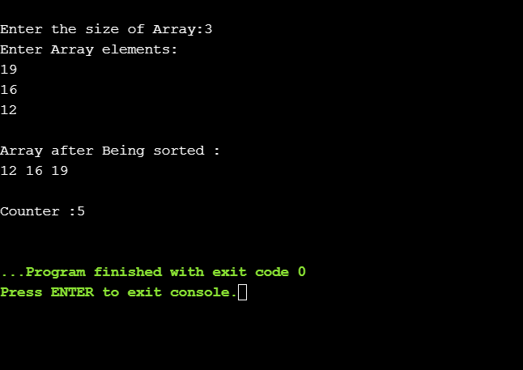

**ANALYSIS TABLE:**

|  |  |
| --- | --- |
| **Size of Array** | **Counter** |
| 3 | 5 |
| 10 | 39 |
| 11 | 46 |
| 7 | 25 |
| 9 | 8 |

**GRAPH:**

**CONCLUSION:**

In this practical we analyzed the behavior of Insertion Sort graph.